SQL Advanced Analytics Project
- Change Over Time Analysis:
--Yearly Trends Analysis
Query:
SELECT
YEAR(order_date) AS Order_Year,
SUM(sales_amount) AS 'Total Revenue',
COUNT(DISTINCT customer_key) AS Total_customers,
SUM(quantity) Total_Qty
FROM gold.fact_sales
WHERE order_date IS NOT NULL
GROUP BY YEAR(order_date)
ORDER BY YEAR(order_date)
Output:
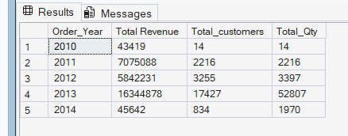

-- Monthly Trends Analysis
Query:
SELECT
DATETRUNC(MONTH,order_date) AS Order_Date,
SUM(sales_amount) AS 'Total Revenue',
COUNT(DISTINCT customer_key) AS Total_customers,
SUM(quantity) Total_Qty
FROM gold.fact_sales
WHERE order_date IS NOT NULL
GROUP BY DATETRUNC(MONTH,order_date)
ORDER BY DATETRUNC(MONTH,order_date)
Output:

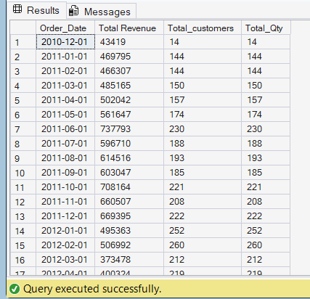

- Cumulative Analysis:
--Calculate the Total Sales per month and the running total and Moving Average of sales over time

Query:

SELECT
Order_Date,
Total_Sales,
SUM(Total_Sales) OVER(PARTITION BY YEAR(order_date) ORDER BY Order_Date) AS Running_Total,
AVG(Total_Sales) OVER(PARTITION BY YEAR(order_date) ORDER BY Order_Date) AS Moving_Aveage
FROM(
SELECT
DATETRUNC(MONTH,order_date) AS Order_Date,
SUM(sales_amount) AS Total_Sales
FROM gold.fact_sales
WHERE order_date IS NOT NULL
GROUP BY DATETRUNC(MONTH,order_date)
)t
Output:
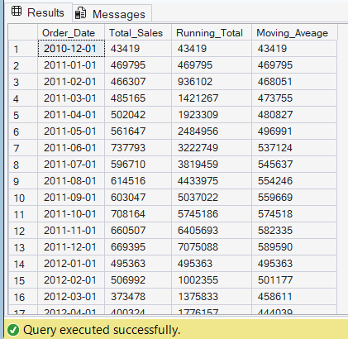

- Performance Analysis:
/*Analyse the Yearly Performance of products by comparing each product's sales to
both its average sales performance and the previous year's sales */

Query:
--Creating CTE - Common Table Expression

WITH Yearly_Product_Sales AS (
SELECT
YEAR(f.order_date) AS Order_Year,
p.product_name,
SUM(f.sales_amount) AS Current_Sales
FROM gold.fact_sales f
LEFT JOIN gold.dim_products p
ON p.product_key=f.product_key
WHERE f.order_date IS NOT NULL
GROUP BY
p.product_name,
YEAR(order_date)
)

SELECT
Order_Year,
product_name,
Current_Sales,
AVG(Current_Sales) OVER(PARTITION BY product_name) AS Avg_Sales,
Current_Sales-AVG(Current_Sales) OVER(PARTITION BY product_name) AS Diff_Avg,
CASE WHEN Current_Sales-AVG(Current_Sales) OVER(PARTITION BY product_name) >0 THEN 'Above Avg'
WHEN Current_Sales-AVG(Current_Sales) OVER(PARTITION BY product_name) <0 THEN 'Below Avg'
ELSE 'Average'
END Avg_change,
--Year-over-year Analysis
LAG(Current_Sales) OVER(PARTITION BY product_name ORDER BY Order_Year) AS Previous_Year_Sales,
Current_Sales-LAG(Current_Sales) OVER(PARTITION BY product_name ORDER BY Order_Year) AS Diff_Py,
CASE WHEN Current_Sales-LAG(Current_Sales) OVER(PARTITION BY product_name ORDER BY Order_Year)>0 THEN 'Increase'
WHEN Current_Sales-LAG(Current_Sales) OVER(PARTITION BY product_name ORDER BY Order_Year) <0 THEN 'Decrease'
ELSE 'No Change'
END Py_Change
FROM Yearly_Product_Sales
ORDER BY product_name, Order_Year

Output:
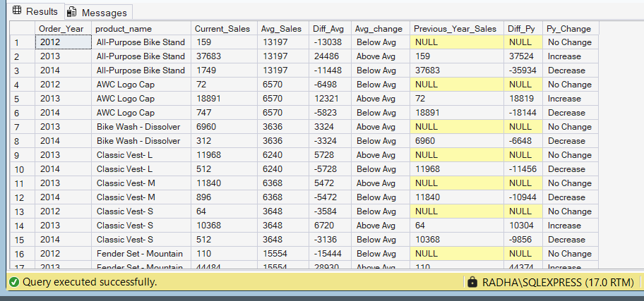

- Part To Whole Analysis:
--Which Categories contributes the most to overall sales

Query:

SELECT
category,
Total_Revenue,
SUM(Total_Revenue) OVER() AS Overall_Sales,
CONCAT(ROUND((CAST(Total_Revenue AS FLOAT)/SUM(Total_Revenue) OVER())*100,2),'%') AS '%OfSales'
FROM
(SELECT
p.category,
SUM(f.sales_amount) AS Total_Revenue
FROM gold.fact_sales f
LEFT JOIN gold.dim_products p
ON f.product_key=p.product_key
GROUP BY p.category)t
ORDER BY Total_Revenue DESC
Output:
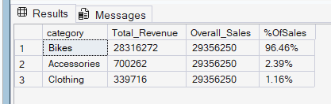

- Data Segmentation Analysis:

/* Segment products into cost ranges and
count how many products fall into each category*/

Query:

WITH Cost_Segment AS (
SELECT
product_name,
cost,
CASE WHEN cost BETWEEN 0 AND 300 THEN '0-300'
WHEN cost BETWEEN 301 AND 600 THEN '301-600'
WHEN cost BETWEEN 601 AND 900 THEN '601-900'
WHEN cost BETWEEN 901 AND 1200 THEN '901-1200'
WHEN cost BETWEEN 1201 AND 1500 THEN '1201-1500'
ELSE '1500 +'
END Cost_range
FROM gold.dim_products)
SELECT
Cost_range,
COUNT(product_name) AS Total_Products
FROM Cost_Segment
GROUP BY Cost_range
ORDER BY COUNT(product_name) DESC
Output:
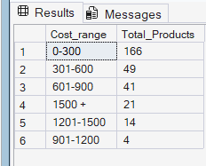

/* Group Customers into three Segments based on their Spending behaviour:
- VIP : Customers with at least 12 Months of history and spending more than $5,000.
- REGULAR : Customers with at least 12 Months of history and spending $5,000 or less.
- NEW : Customers with Lifespan less than 12 months
and find the total number of customers by each Group*/

Query:

--1st CTE
WITH Order_Details AS (
SELECT
customer_key,
SUM(sales_amount) AS Total_Sales,
DATEDIFF(MONTH,MIN(order_date),MAX(order_date)) AS LifeSpan
FROM gold.fact_sales
GROUP BY customer_key),
--2nd CTE
Segment_details AS (
SELECT *,
CASE WHEN Total_Sales >5000 AND LifeSpan>= 12 THEN 'VIP'
WHEN Total_Sales <=5000 AND LifeSpan >= 12 THEN 'REGULAR'
ELSE 'NEW'
END Segment_Category
FROM Order_Details)
--Main Query
SELECT
Segment_Category,
COUNT(customer_key) AS Customer_count
FROM Segment_details
GROUP BY Segment_Category
ORDER BY COUNT(customer_key) DESC

Output:
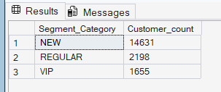

- Customer Report:
/* =======================================================================
Customer Report
==========================================================================
Purpose:
- This report consolidates key customer metrics and behaviours
Highlights:
1. Gather essential fields such as Names, ages, and transaction details.
2. Segment Customers in to 3 categories (VIP, Regular, New) and age groups
3. Aggregate Customer Level metrics:
- Total Orders
- Total Sales
- Total Quantity Purchased
- Total Products
- Lifespan (in Months)
4. Calculate Valuable KPI's
- Recency (months since last order)
- Average Order Value
- Average Monthly spends
=========================================================================*/
Query:
CREATE VIEW gold.report_customers
AS
WITH Base_Query AS (
/*-------------------------------------------------------------------
1. Base Query: Retrieves core fields from tables
-------------------------------------------------------------------*/
SELECT
f.order_number,
f.product_key,
f.order_date,
f.sales_amount,
f.quantity,
c.customer_key,
c.customer_id,
c.customer_number,
CONCAT(c.first_name,' ',c.last_name) AS Customer_Name,
DATEDIFF(YEAR, c.birthdate,CURRENT_DATE) AS Age
FROM gold.fact_sales f
LEFT JOIN gold.dim_customers c
ON c.customer_key = f.customer_key
WHERE order_date IS NOT NULL),
Customer_aggregation AS (
/*-------------------------------------------------------------------
2. Customer Aggregations: Summarizes key metrics at the customer level
-------------------------------------------------------------------*/
SELECT
Customer_Name,
customer_key,
customer_number,
Age,
MAX(order_date) AS Last_order,
COUNT( DISTINCT order_number) AS Total_Orders,
SUM(sales_amount) AS Total_Sales,
SUM(quantity) AS Total_Qty_Purchased,
COUNT(DISTINCT product_key) AS Total_Products,
DATEDIFF(MONTH,MIN(order_date),MAX(order_date)) AS Lifespan
FROM Base_Query
GROUP BY
Customer_Name,
customer_key,
customer_number,
Age
)
SELECT
Customer_Name,
customer_key,
customer_number,
Age,
CASE WHEN Age <20 THEN 'Under 20'
WHEN Age BETWEEN 21 AND 40 THEN '21-40'
WHEN Age BETWEEN 41 AND 60 THEN '41-60'
WHEN Age BETWEEN 61 AND 80 THEN '61-80'
WHEN Age BETWEEN 81 AND 100 THEN '81-100'
ELSE 'Above 100'
END Age_Group,
Lifespan,
CASE WHEN Total_Sales >5000 AND Lifespan >=12 THEN 'VIP'
WHEN Total_Sales <=5000 AND Lifespan >=12 THEN 'Regular'
ELSE 'New'
END Customer_category,
Last_Order,
DATEDIFF(MONTH,Last_order, CURRENT_DATE) AS Recency,
Total_orders,
Total_Sales,
Total_Qty_Purchased,
Total_Products,
--Compute Average order Value
CASE WHEN Total_Orders = 0 THEN 0
ELSE Total_Sales/Total_Orders
END Average_Order_Value,
--Compute Average Monthly Spends
CASE WHEN Lifespan =0 THEN Total_sales
ELSE Total_sales/Lifespan
END Average_Monthly_Spends
FROM Customer_aggregation

Output:
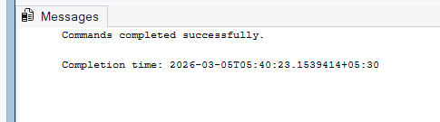

/*
=====================================================================
Product Report
=====================================================================
Purpose:
- This report consolidates key Product metrics and behaviours
Highlights:
1. Gather essential fields such as Product Names, Category, Subcategory, and Cost details.
2. Segment Product by Revenue to identify High-performers, Mid-Range, or Low-performers.
3. Aggregate Product Level metrics:
- Total Orders
- Total Sales
- Total Quantity Sold
- Total Customers (Unique)
- Lifespan (in Months)
4. Calculate Valuable KPI's
- Recency (months since last Sale)
- Average Order Revenue
- Average Monthly Revenue
=====================================================================
*/
CREATE VIEW gold.report_Product AS
WITH Base_query AS (
/*-------------------------------------------------------------------
1. Base Query: Retrieves core fields from tables
-------------------------------------------------------------------*/
SELECT
f.order_number,
f.customer_key,
f.order_date,
f.sales_amount,
f.quantity,
p.product_key,
p.product_name,
p.category,
p.subcategory,
p.cost
FROM gold.fact_sales f
LEFT JOIN gold.dim_products p
ON p.product_key = f.product_key
WHERE order_date IS NOT NULL
),
Key_metrics AS(
/*-------------------------------------------------------------------
2. Product Aggregations: Summarizes key metrics at the Product level
-------------------------------------------------------------------*/
SELECT
product_key,
product_name,
category,
subcategory,
cost,
MAX(order_date) AS Last_Order_Date,
DATEDIFF(MONTH,MIN(order_date),MAX(order_date)) AS Lifespan,
COUNT(DISTINCT order_number) AS Total_Orders,
SUM(Sales_amount) AS Total_Revenue,
SUM(quantity) AS Total_qty_sold,
COUNT(DISTINCT(customer_key)) AS Total_customers
FROM Base_query
GROUP BY
product_name,
category,
subcategory,
cost,
product_key
)
--Main Query
SELECT
product_name
category,
subcategory,
cost,
Last_Order_date,
DATEDIFF(MONTH,Last_Order_Date,GETDATE()) AS Recency_In_Months,
CASE WHEN Total_Revenue >10000 THEN 'High-performers'
WHEN Total_Revenue BETWEEN 5000 AND 10000 THEN 'Mid-range'
ELSE 'Low-performers'
END Product_Segment,
Lifespan,
Total_Orders,
Total_Revenue,
Total_Customers,
--Average Order Revenue
CASE WHEN Total_Orders = 0 THEN 0
ELSE Total_Revenue/Total_Orders
END Avg_Order_Revenue,
--Average Monthly Revenue
CASE WHEN Lifespan = 0 THEN Total_Revenue
ELSE Total_Revenue/Lifespan
END Avg_Monthly_Revenue
FROM Key_metrics

Output:

